API INTEGRATION AND SCHEMA AND SCHEMA ADJUSTMENT REPORT

**NAME : HAFIZ ABDUR REHMAN**

**E COMMERCE MARKET PLACE REPORT**

**This report explain the step to import API adjust in the sanity CMS and display data on the frontend**

API INTEGRATION PROCESS .

GET/ PRODUCT ; GET LIST OF PRODUCT

GET/CATEGORY: GET LIST OF CATEGORY

DATA MIGRATION

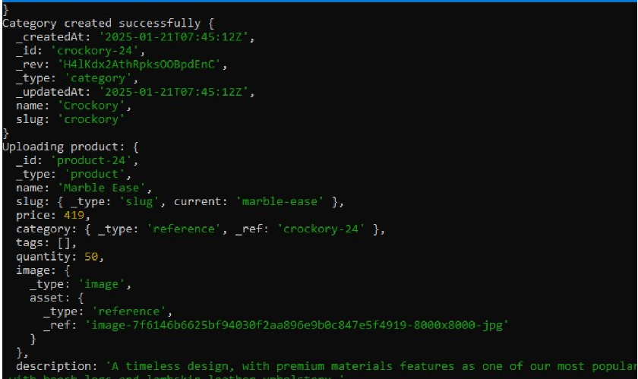

FETCH DATA API

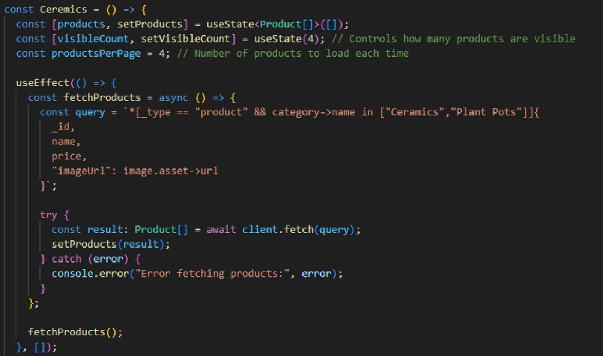

Product

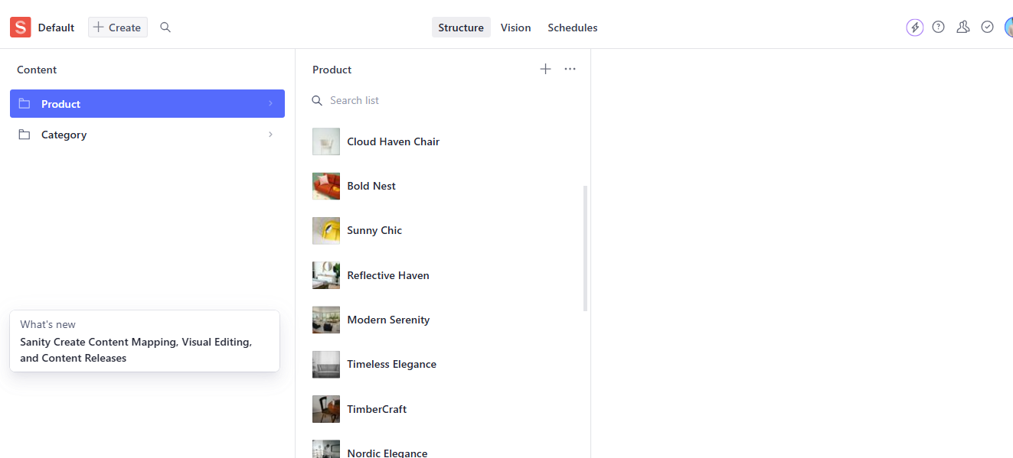

IMPORTED COMPLETE

